Memory Allocation Project

## Memory management brief introduction

* What is the function of memory management?

The memory management function In [operating systems](https://en.wikipedia.org/wiki/Operating_system) is to keep track o the status either allocated or free. When memory is going to be allocated it determines where it should be allocated. It has all the memory (free and allocated) and tracks its status frequently.

* The memory management system provides:

1. Large Address Space
2. Protection
3. Memory Mapping
4. Physical Memory Allocation for Processes
5. Shared Virtual Memory

* A screenshot of a cell phone

  Description automatically generatedSegmentation:

Segmentation is a memory management technique that divided each process into several segments with different sizes for each segment, for example, dividing the module into factions. And allocate each segment separately in the address space.

When a process is going to execute, we check the segmentation table to get the segments needed for the execution.

## Requirements For Memory Allocation and Memory deallocation Project

* **Inputs:**
* the data of the process name and segment number.
* the segment’s name and size.
* Allocation algorithm first or best algorithm.
* Deallocate a process.
* Deallocation address (for deallocating form system).
* **Output:**
* Draw the memory space (holes, allocated for processes, allocated for the system).
* Segmentation Table.

## Parts of the project

* + Design and Implement GUI.
  + Design and Implement The Logic.

### Design GUI

This GUI is designed to be simple and easy to use as we would see in the user guide.

Figure 23:Gui Design

#### User Guide

1. Enter the size of the memory then a block of memory with this size would be drawn in the Graphics view on the Right.
2. Enter the start and size for a hole then Click add hole, A hole at the start would add by the size.
3. Entre the start of An allocated block you want to deallocate from the system and Click the Deallocate Button, the block would be free.
4. Add the process name and the segment number then it would appear in the Process Data compo box to enter its data.
5. Then choose the process you want and insert the segments’ name and their size.
6. If you entered all the process segments then you are able to choose the allocation algorithm and click allocate and the memory space would be updated if the process is successfully allocated else an error message would appear.
7. To deallocate a process chose it from the compo box and click deallocate it would be deallocated, and the block memory would be updated.

#### Flow Chart

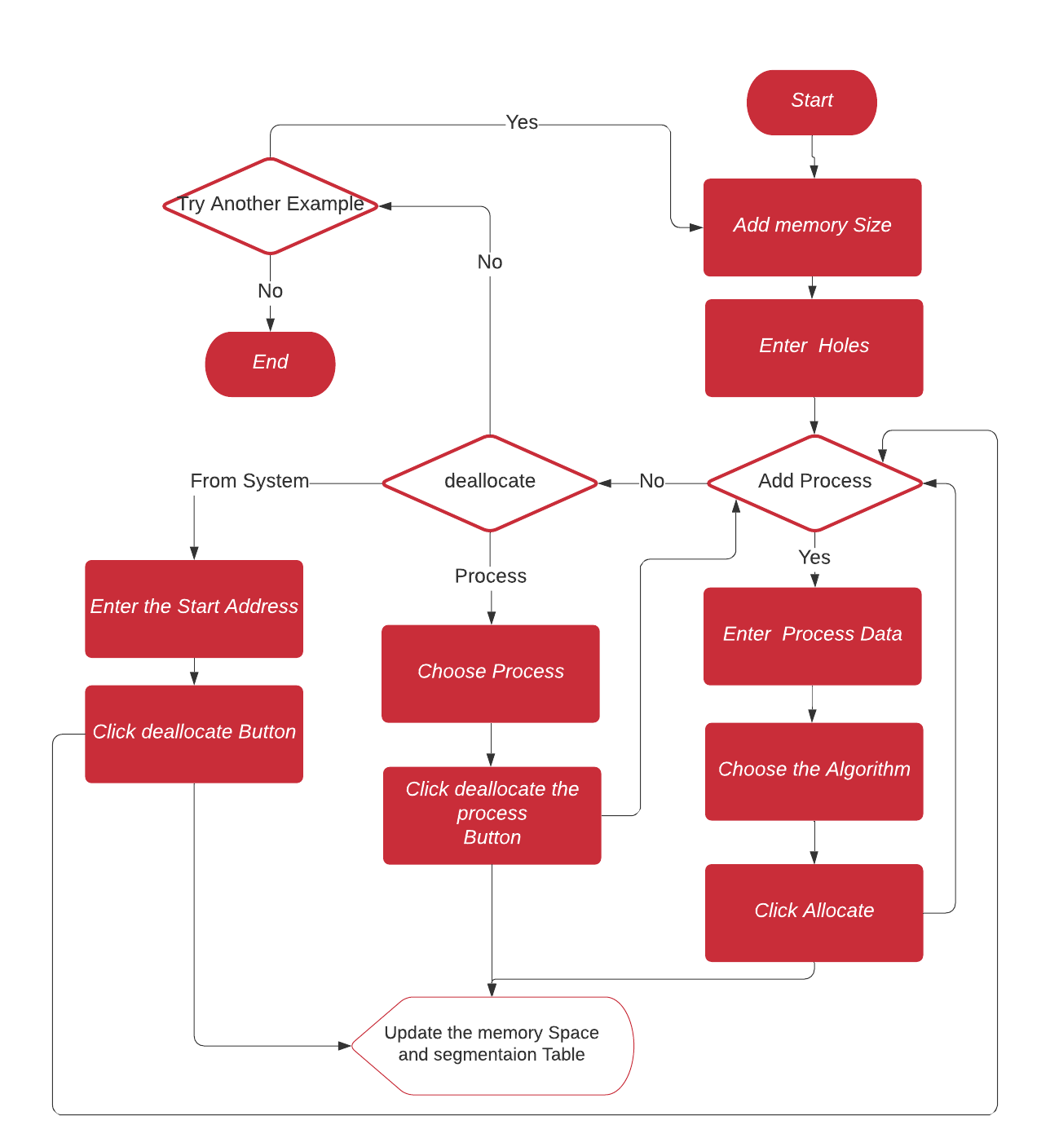

Figure 24:Gui Flow Chart.

#### Sample of Warning messages, that prevent the user from any expected errors

Figure 25: if you click on the process to deallocate.

Figure 26:process can’t allocate as one or more segment does not have a suitable space

Figure 27:when trying deallocate a process segment.

Figure 28:indecation for the process has all the segments

And there are more Warning messages, that I made to make the testing phase much easier.

### Algorithms Logic Design

I implement both first and best algorithms on code blocks first, then merge them with the qt GUI.

And the implementation gave the user many options like using Both the first and best Algorithm in the same example, but with different processes.

#### Example

* Initiate the system with holes (100,50),(200,100),(400,150).A screenshot of a cell phone

  Description automatically generated

##### A screenshot of a cell phone Description automatically generatedFirst allocation example:

Then add process with segments Simulink(110),simlink2(40) ,code(40),code2(10).

##### best allocation example:

Then add process with segments Simulink(110),simlink2(40) ,code(40),code2(10).

#### Class diagram

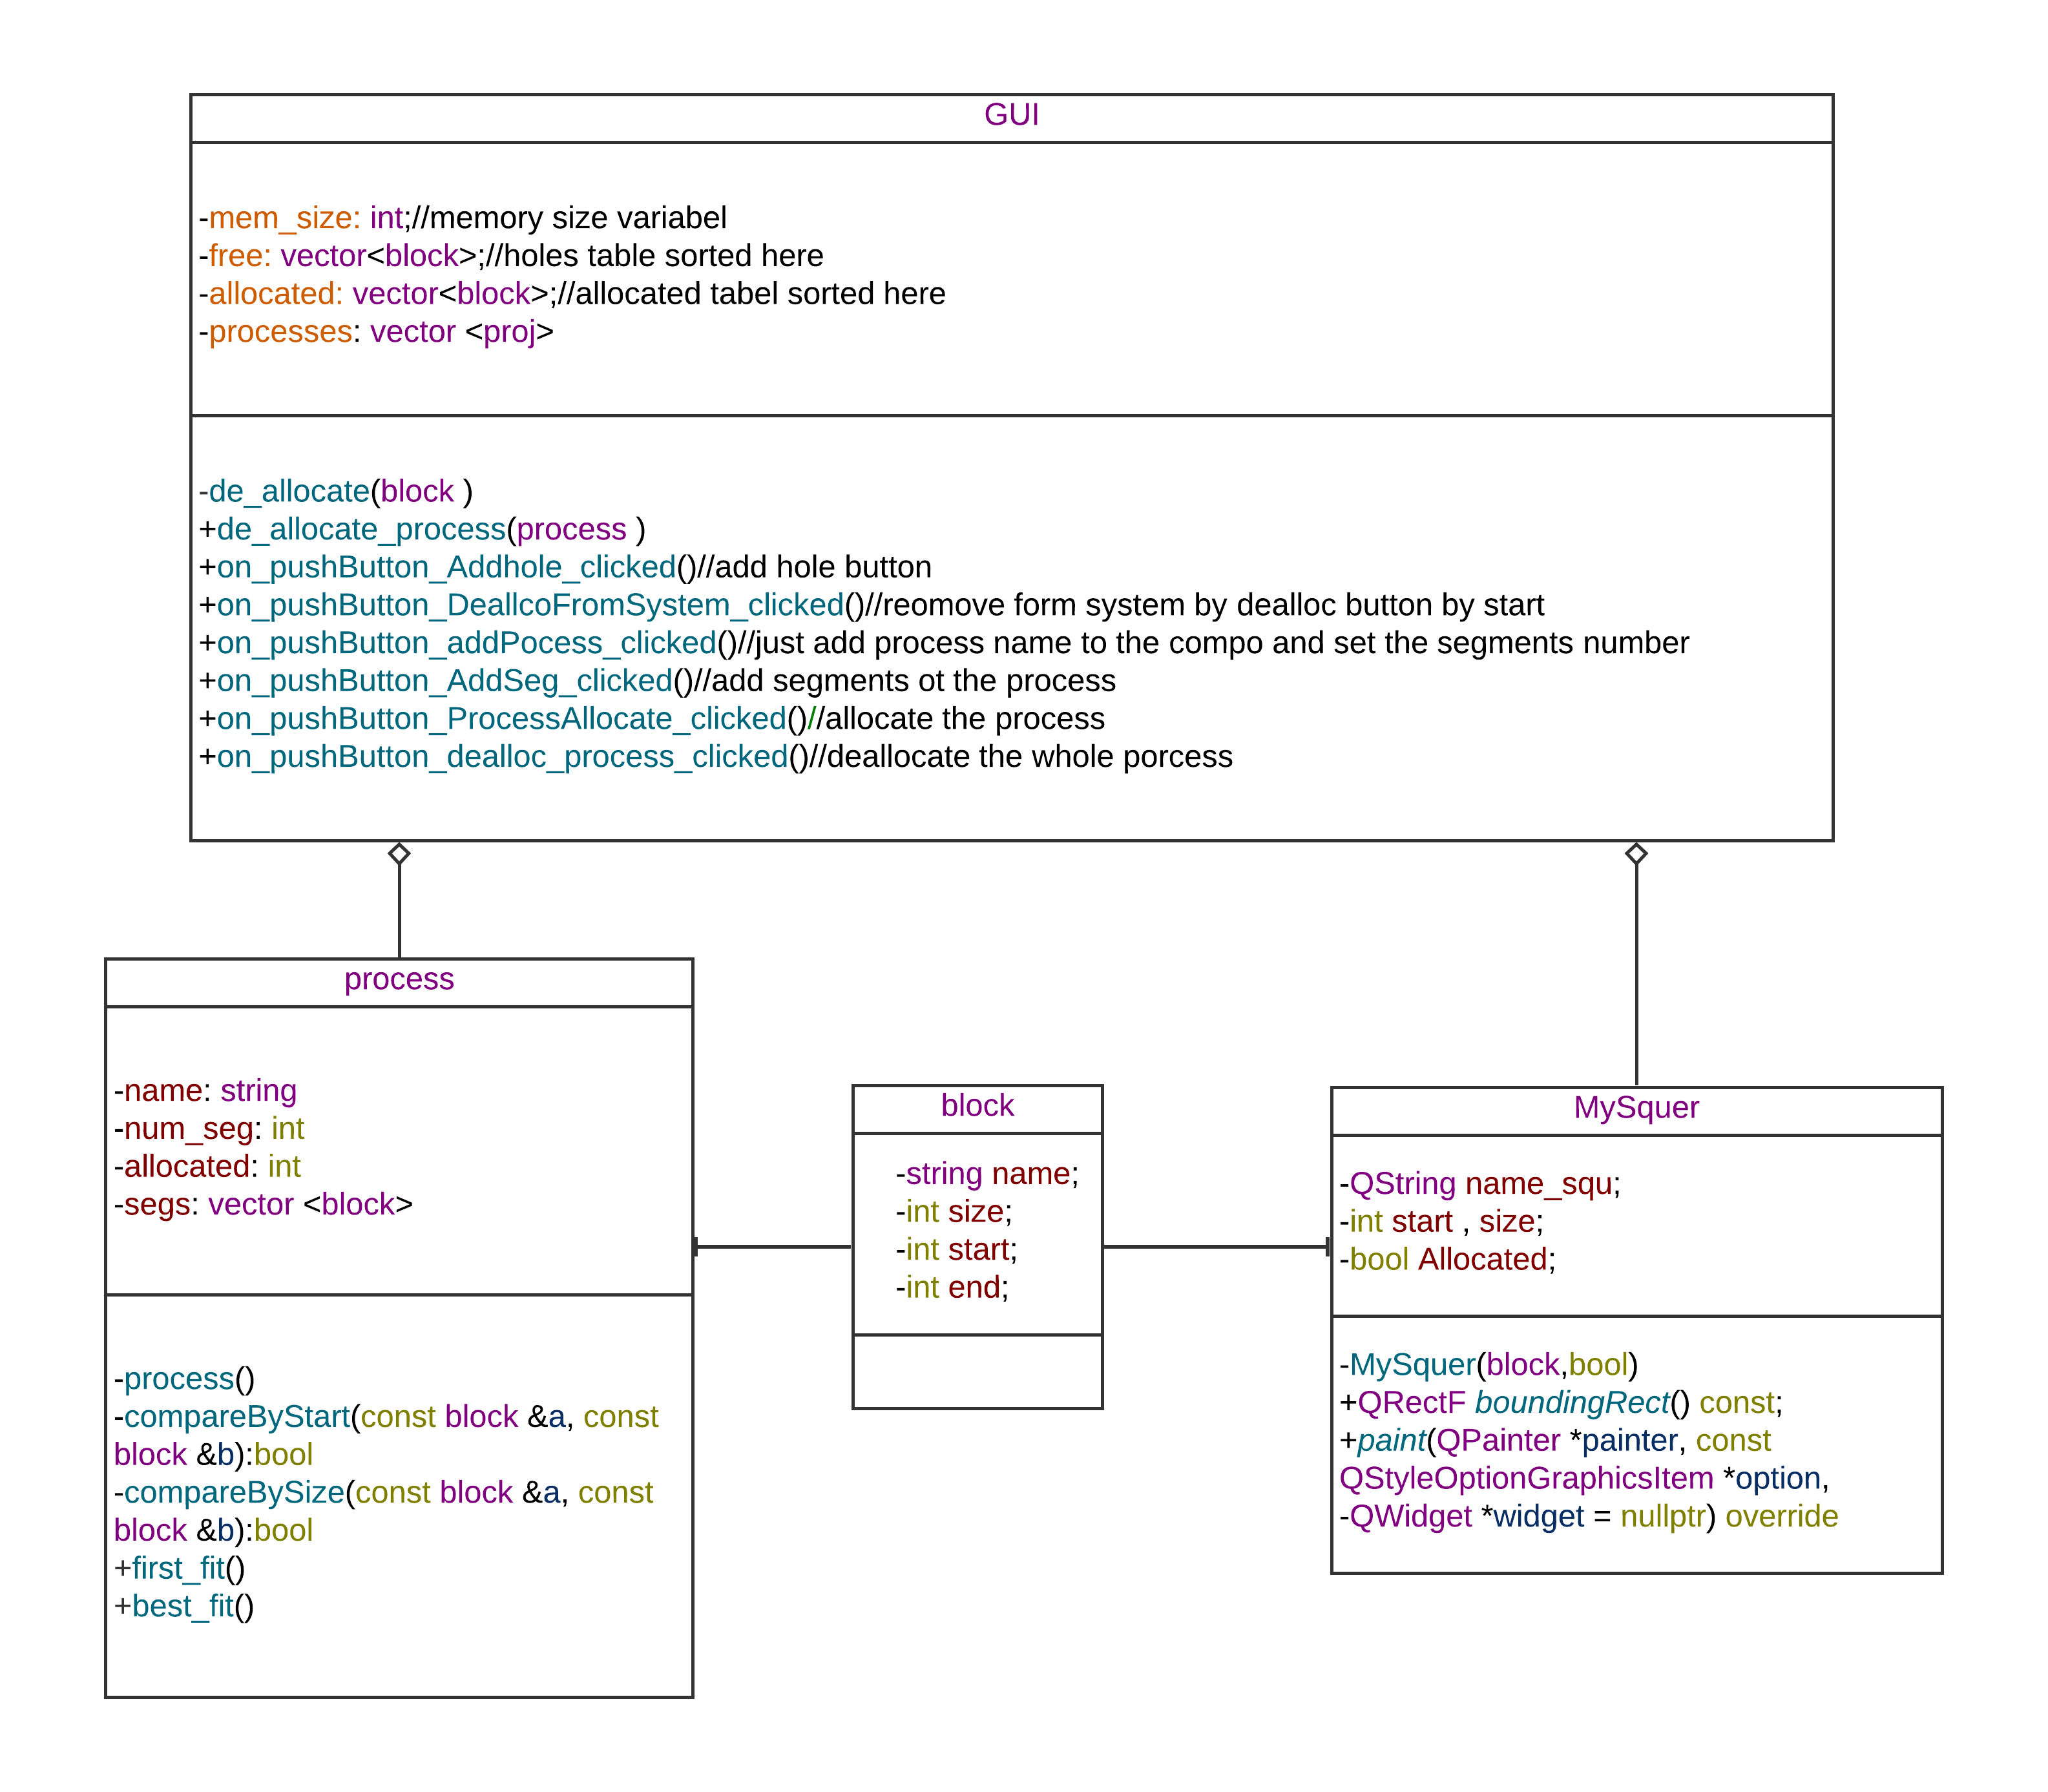

#### Classes Description

* class block represents the block Which is one of three(a hole, allocated for a process, allocated for the System), we use this also to Draw in the GUI.
* Class MySquer I just made it to inherit from the library, that I use to draw a square in the Graphics View.
* The class process represents the process with its name, and segments and they include the segmentation table.
* Class GUI is used for interfacing, taking data, and making actions(messages, drawing memory space, drawing segmentation table).